Lab - Provision a Azure Container Application and Deploy a Node Application
In this lab, we will learn another Azure Service “Azure Container Apps”.

Azure Container Apps is a fully managed environment that enables you to run microservices and containerized applications on a serverless platform.
Common uses of Azure Container Apps include:
- Deploying API endpoints
- Hosting background processing applications
- Handling event-driven processing
- Running microservices
Applications built on Azure Container Apps can dynamically scale based on: HTTP traffic, event-driven processing, CPU or memory load.

Learning Objectives:

Provision an Azure Container Application using Azure Portal and Deploy a Node application

Steps to follow:

Step 1 - Create a Docker Image
We will deploy a sample standalone node application on Azure Container App. Follow the steps mentioned to create the image and push it to Dockerhub Registry.

- Clone the code repository - Sample Node Application

Note - This is the sample image we used in one of the previous labs but we will create the image again as we need an image created with some specific options. Follow the steps to find out.

- Add a file with name Dockerfile and add the following code

# Use an official Node.js runtime as the base image
FROM node:18-alpine
# Set the working directory in the container
WORKDIR /app
# Copy package files and install dependencies
COPY package*.json ./
RUN npm install
# Copy the rest of the application code
COPY . .
# Expose the port that the app runs on
EXPOSE 3000
# Define the command to run the app
CMD ["node", "server.js"]

- Build the image with the following command.

docker build --platform linux/amd64 -t saurabhd2106/nodeapp:linux_amd64 .

Notice - nodeapp:linux_amd64, this is to match the linux platform on Container App.

- Login and Push the docker image to docker hub.

docker login

Enter the credentials (steps are same as the last lab)

docker push saurabhd2106/nodeapp:linux_amd64

Step 2 - Provision a Azure Container Application

- Sign In to the Azure Portal
- Create a Container Application

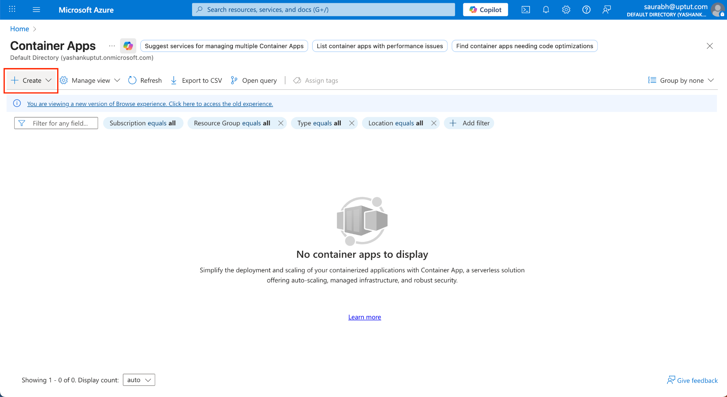

Enter the details like -

- Resource Group Name, example - devops-rg-container-lab
- Container Name, example - devops-node-app
- Deployment Source: Container Image, since we are deploying a container, we will create our own image and attach it here.

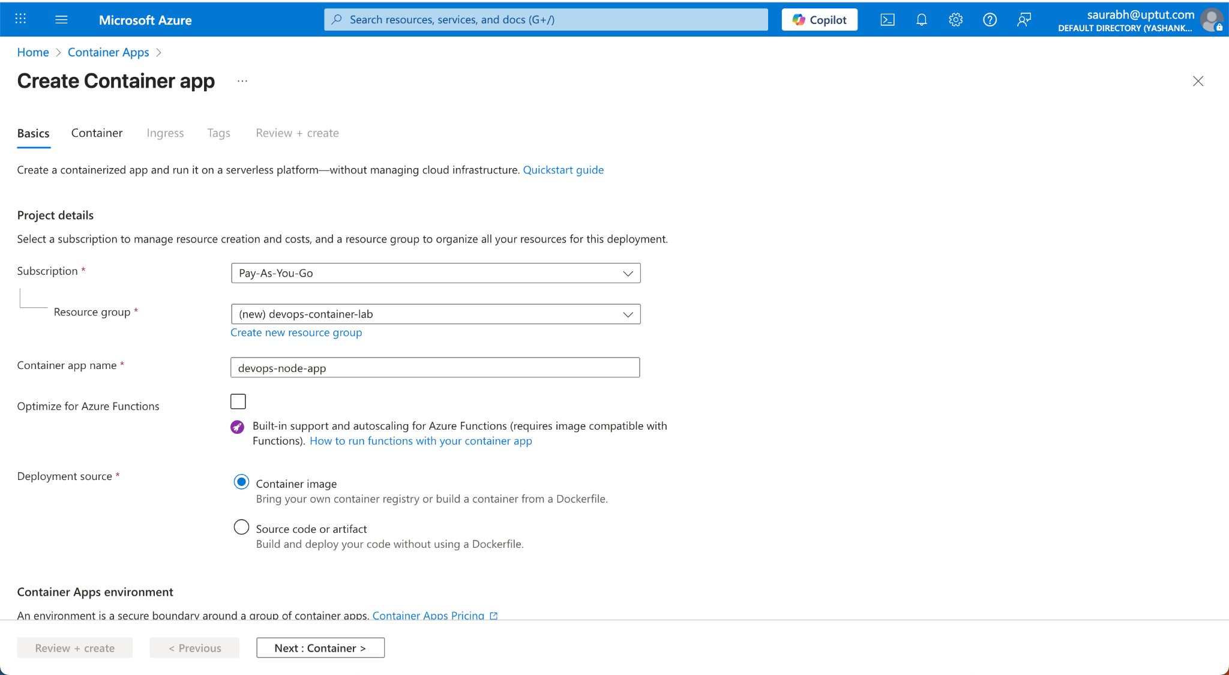

Add the Container details -
- Name: devops-node-app
- Image Source - Dockerhub or other registries (You can use the Azure Container Registry also). Since we have pushed the image on Dockerhub we will use it.
- Registry Authentication
  - Authentication Type - Secret-Based
  - Registry Username - <your username of the dockerhub>
  - Registry Password - Access Token of your dockerhub registry

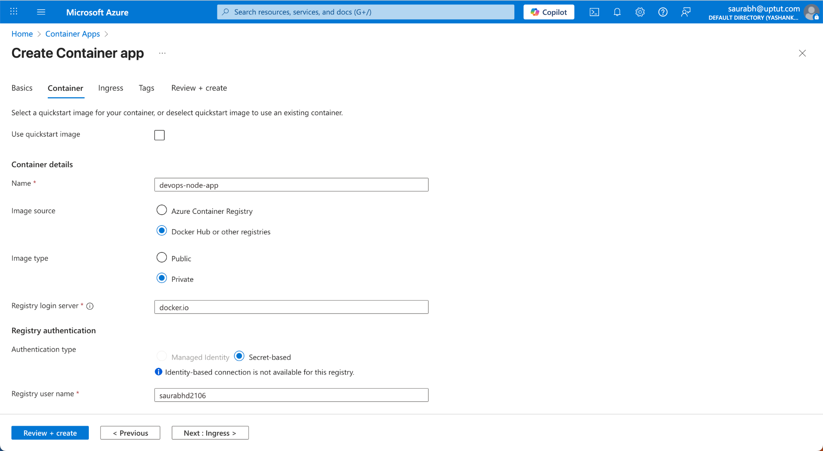

Enter the name of the Container Application

- Image and Tag - Enter the name of the image you create in the step 1
- Rest everything as default

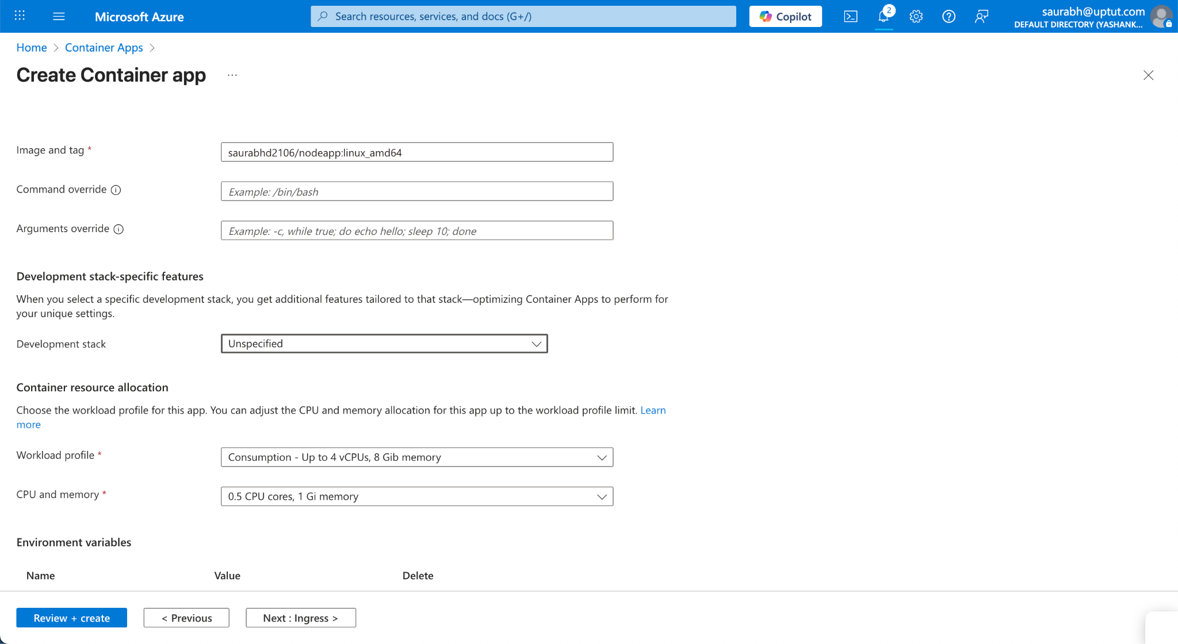

Under Ingress settings
- Enable Ingress
- Target Port - 3000
- Keep all other configuration same, Click Review + Create

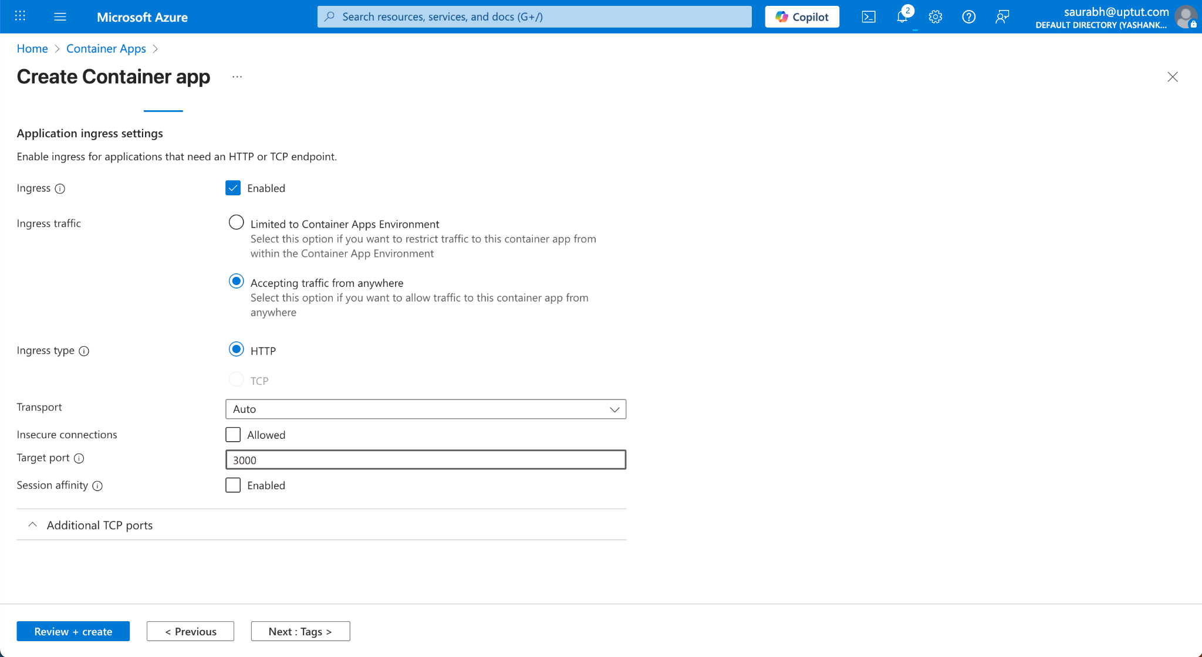

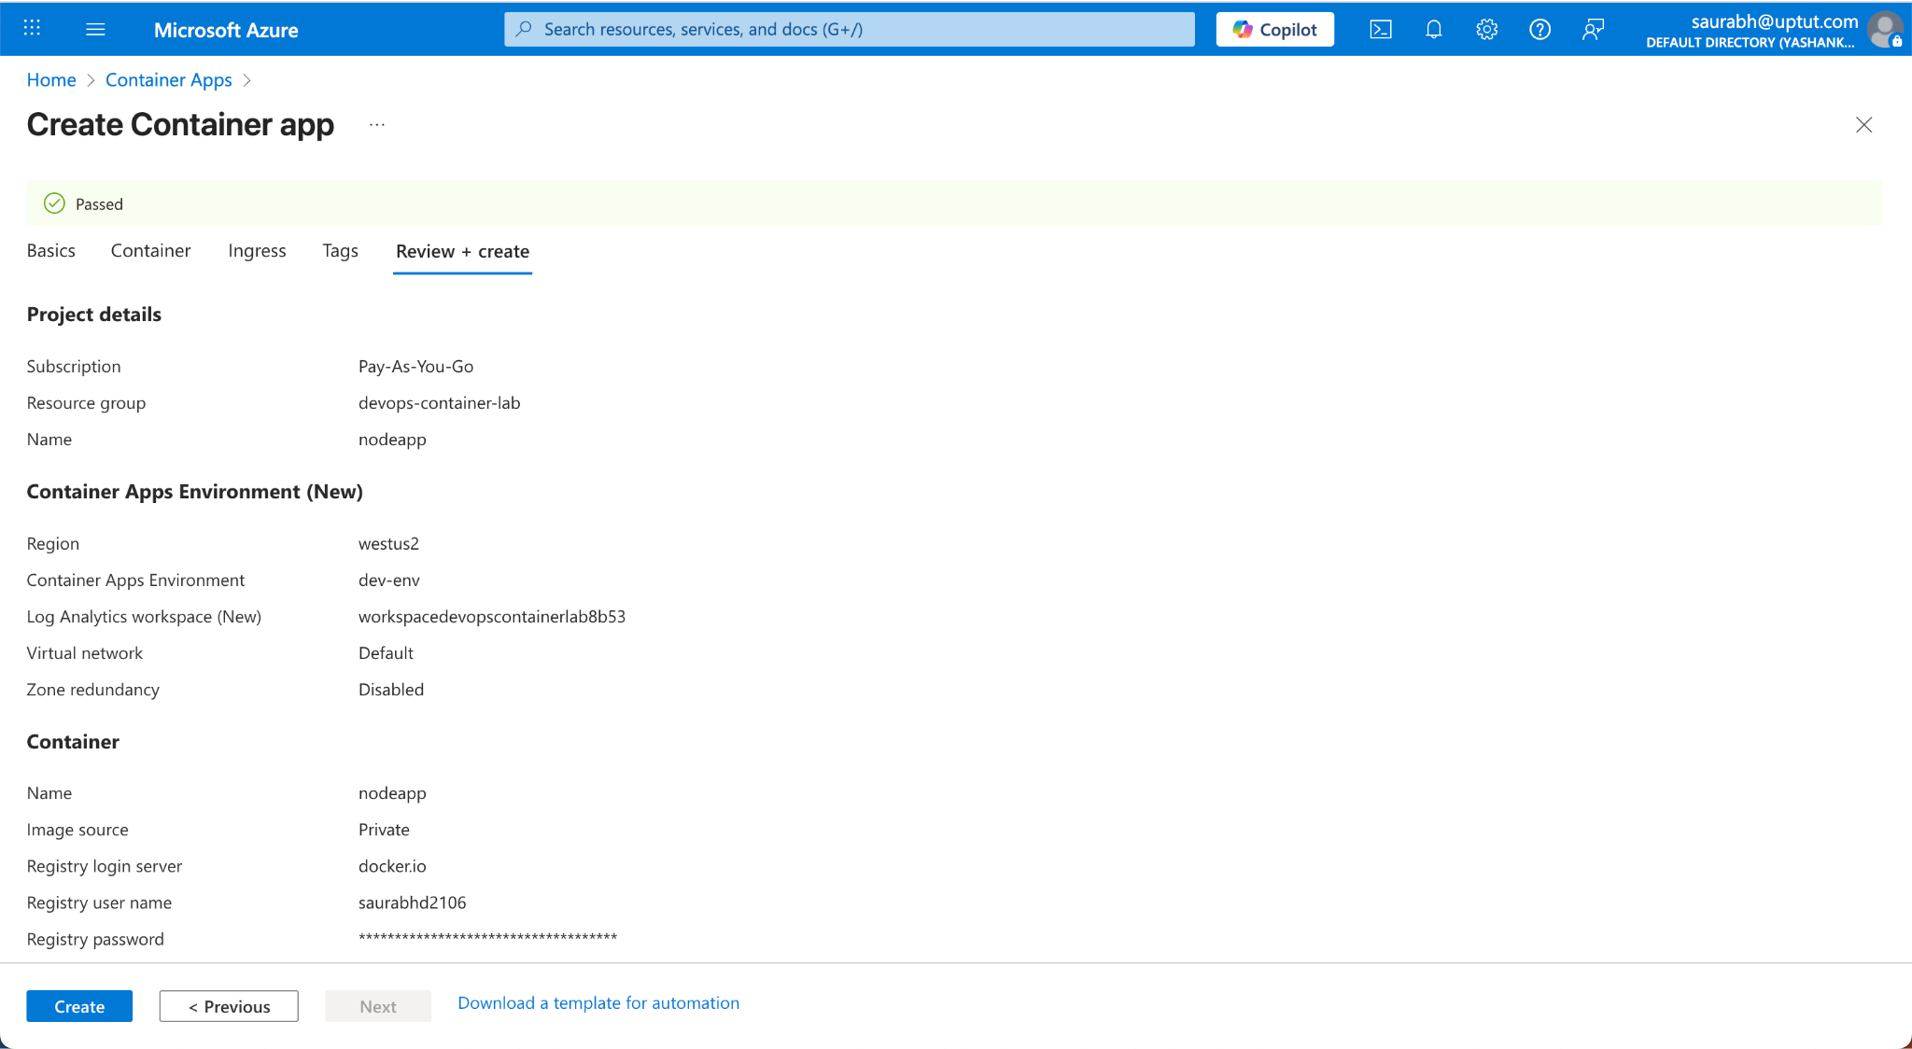

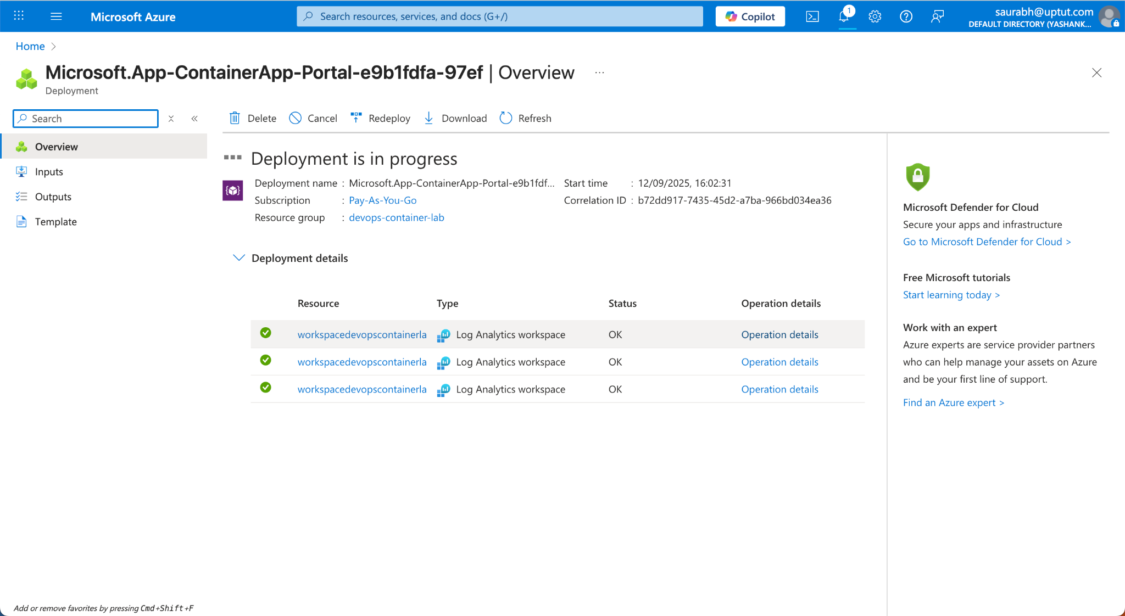

Once the deployment is complete. Navigate to overview page of the Container App and get the url.

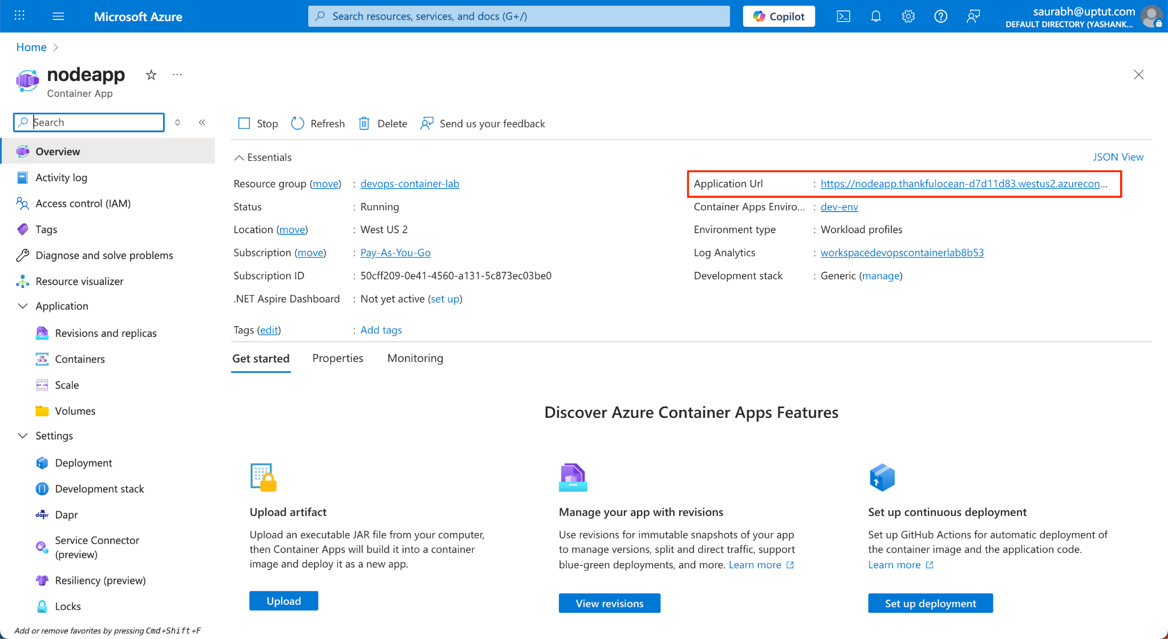

Navigate to the URL of the container to see the application running.

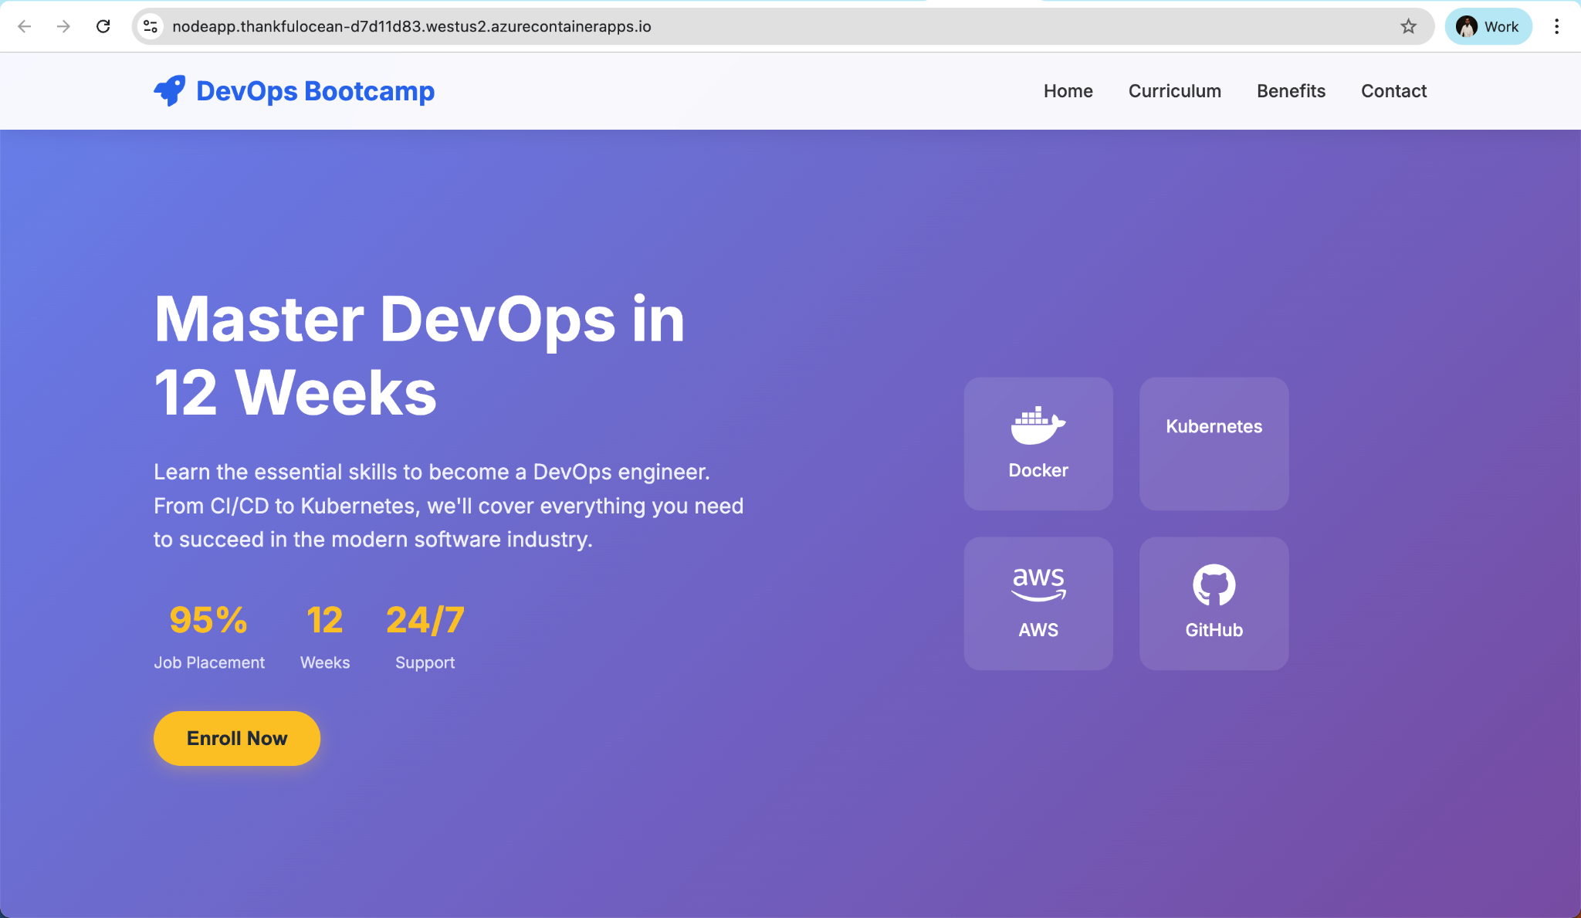

Congratulations! You have successfully deployed a standalone application on Azure Container App

